**1.**

#include <stdio.h>

int main() {

int arr[] = {10, 20, 30, 40};

int sum = 0;

int *ptr = arr;

for (int i = 0; i < sizeof(arr) / sizeof(arr[0]); i++) {

sum += *(ptr + i);

}

printf(“Sum of elements: %d”, sum);

return 0;

}

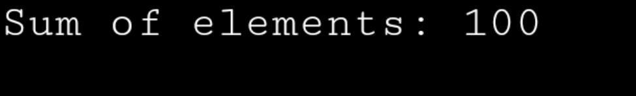

**2.**

#include <stdio.h>

void swap(int *a, int *b) {

int temp;

temp = *a;

*a = *b;

*b = temp;

}

int main() {

int num1 = 10, num2 = 20;

printf(“Before swap: num1 = %d, num2 = %d\n”, num1, num2);

swap(&num1, &num2);

printf(“After swap: num1 = %d, num2 = %d\n”, num1, num2);

return 0;

}

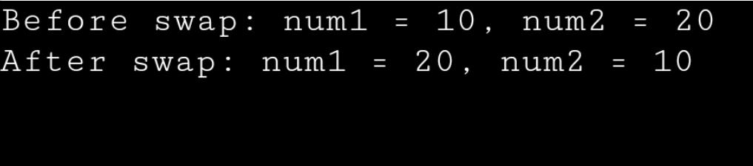

**3.**

#include <stdio.h>

void reverseString(char *str) {

char *start = str;

char *end = str;

char temp;

while (*end != ‘\0’) {

end++;

}

end--;

while (start < end) {

temp = *start;

*start = *end;

*end = temp;

start++;

end--;

}

}

int main() {

char str[100];

printf(“Enter a string: “);

fgets(str, 100, stdin);

reverseString(str);

printf(“Reversed string: %s”, str);

return 0;

}

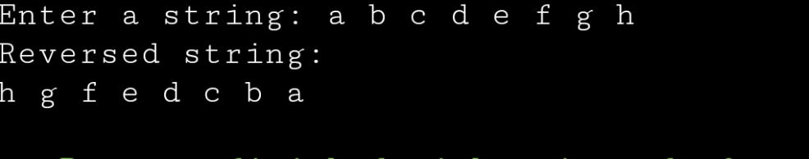

**4.**

#include <stdio.h>

int calculatePower(int base, int exponent) {

int result = 1;

for (int I = 0; I < exponent; i++) {

result *= base;

}

return result;

}

int main() {

int base, exponent;

int (*powerFunction)(int, int) = calculatePower;

printf(“Enter the base: “);

scanf(“%d”, &base);

printf(“Enter the exponent: “);

scanf(“%d”, &exponent);

int result = powerFunction(base, exponent);

printf(“%d to the power of %d is %d\n”, base, exponent, result);

return 0;

}

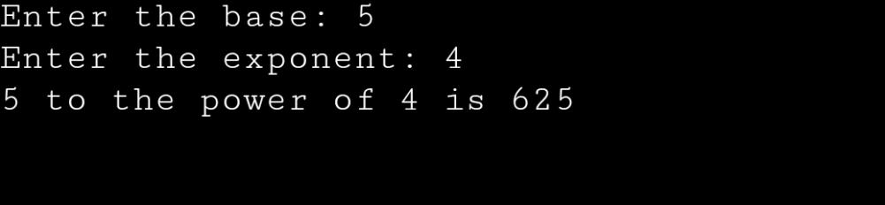

**5.**

#include <stdio.h>

#include <stdlib.h>

int main() {

int rows, cols;

printf(“Enter the number of rows: “);

scanf(“%d”, &rows);

printf(“Enter the number of columns: “);

scanf(“%d”, &cols);

int *arr = (int *)malloc(rows * cols * sizeof(int));

if (arr == NULL) {

printf(“Memory allocation failed.\n”);

exit(1);

}

for (int i= 0; i < rows; i++) {

for (int j = 0; j < cols; j++) {

int index = i* cols + j;

printf(“Enter element at [%d][%d]: “, i, j);

scanf(“%d”, &arr[index]);

}

}

printf(“\nEntered array:\n”);

for (int i= 0; i< rows; i++) {

for (int j = 0; j < cols; j++) {

printf(“%d “, arr[i* cols + j]);

}

printf(“\n”);

}

Free(arr);

return 0;

}

